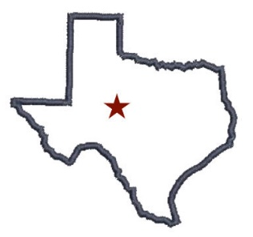

The City of Robert Lee

6 E. 7th St, PO Box 26, Robert Lee, TX 76945

Ph (325) 453-2831 Fax (325) 453-4531

Notice of Scheduled Water Service Interruption

The City of Robert Lee water department is scheduling a partial water outage for Wednesday, September 17th . Those affected are all connections south of 6th Street - West of HWY 208, AND POSSIBLY East of South HWY 208(Coke St, Lucas and Overland Trail). Water service for Coke County Water Supply Corporation will also be interrupted during this time.

The Water outage for this area should last around 4-6 hours and will begin around mid-morning. This isolation is required to replace an old 6-inch water main and valve crossing 3rd Street on Houston and complete additional required connections before the road construction begins. After pressure is restored to the area, a Boil Water Notice will go into effect for the previously mentioned area only -NOT a city-wide notice-. Bacteriological samples will be taken the following day.

If you have any questions or concerns you can contact Robert Lee City Hall at (325) 453-2831 or visit at 6 E 7th St. Robert Lee, Texas 76945.